**ITERATION 1(POTENTIALSTORY-FOW)** We wanted to show how Ai has been implemented in every stage of production of a food item. “FROM FARM-SHELF”

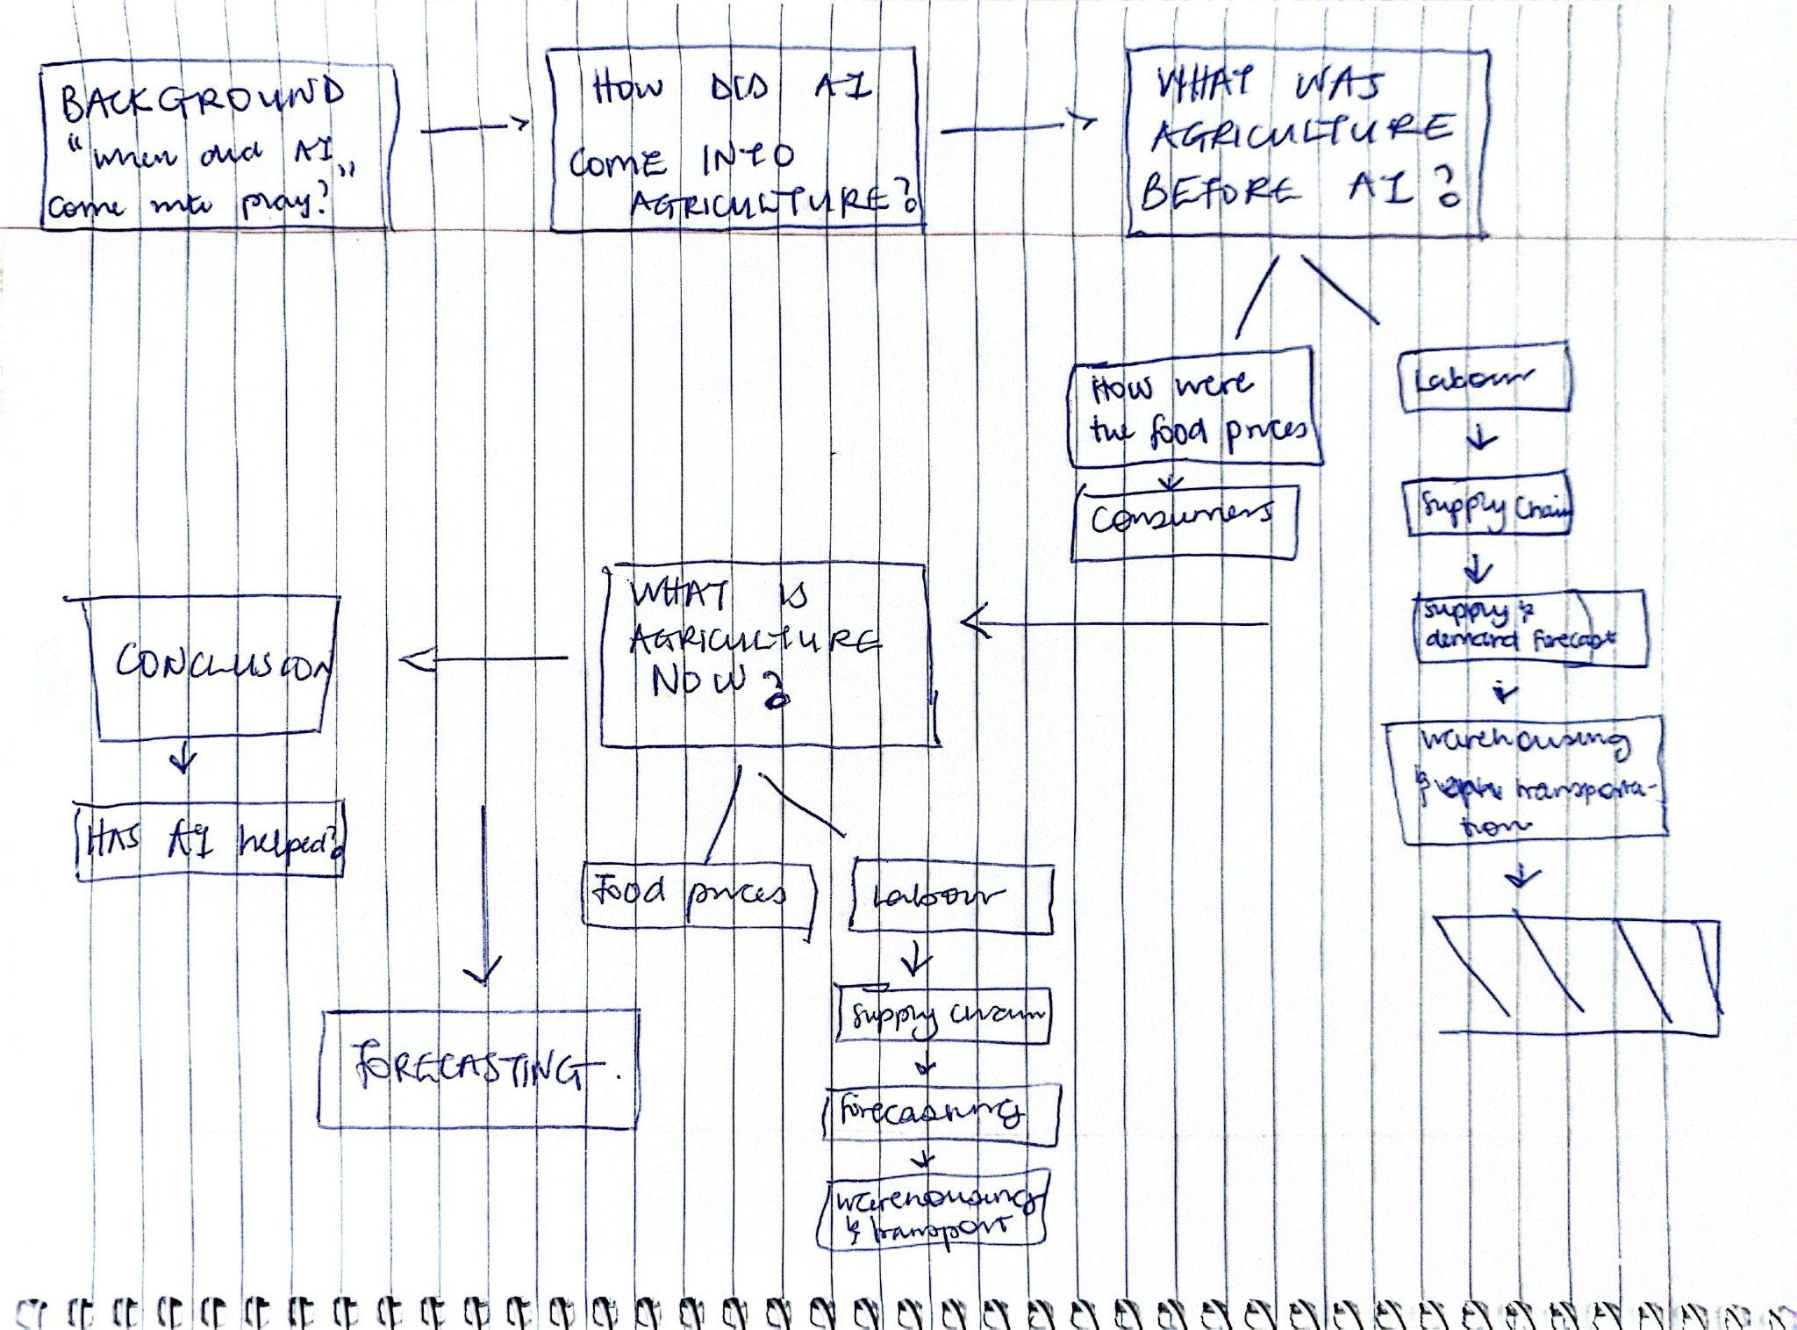

**ITERATION 2 (STORY LINE) - Mini Documentary Scene Outline**

**Scene 1 — Opening Contrast: “Before”**

Black‑and‑white visuals of a shopper before COVID‑19, stable food prices, calm store environment. Includes close-ups of price labels and normal checkout experiences.

**Scene 2 — COVID Hits: ‘The Break’**

Quick cuts of empty shelves, news overlays, muted tones. Shows disruption in food supply chains and sudden price increases.

**Scene 3 — Present Day: Same Person, Same Store, Different Reality**

Full‑color shots of the same shopper reacting to dramatically higher prices. Side‑by‑side comparisons of before vs after.

**Scene 4 — Rising AI: “The Acceleration”**

B‑roll of AI in warehouses, automation, dashboards. Highlights rapid AI adoption post‑COVID.

**Scene 5 — Expert Commentary Montage**

Multiple voices discussing affordability, AI’s impact, and socioeconomic concerns.

**Scene 6 — Scroll‑Telling Visualization Segment**

Screen‑recorded data storytelling using charts, animations, and narrated insights.

**Scene 7 — Food Bank Reality Check**

Respectful shots of food bank operations, illustrating increased usage since COVID.

**Scene 8 — The Critical Question**

Shoppers comparing prices, automation machines, and big question visual overlays about affordability and AI.

**Scene 9 — Closing Reflection**

Shopper leaving with fewer items; fade to black; final message about understanding data as a step toward solutions.

**ITERATION 3**

**SCENE ONE :**

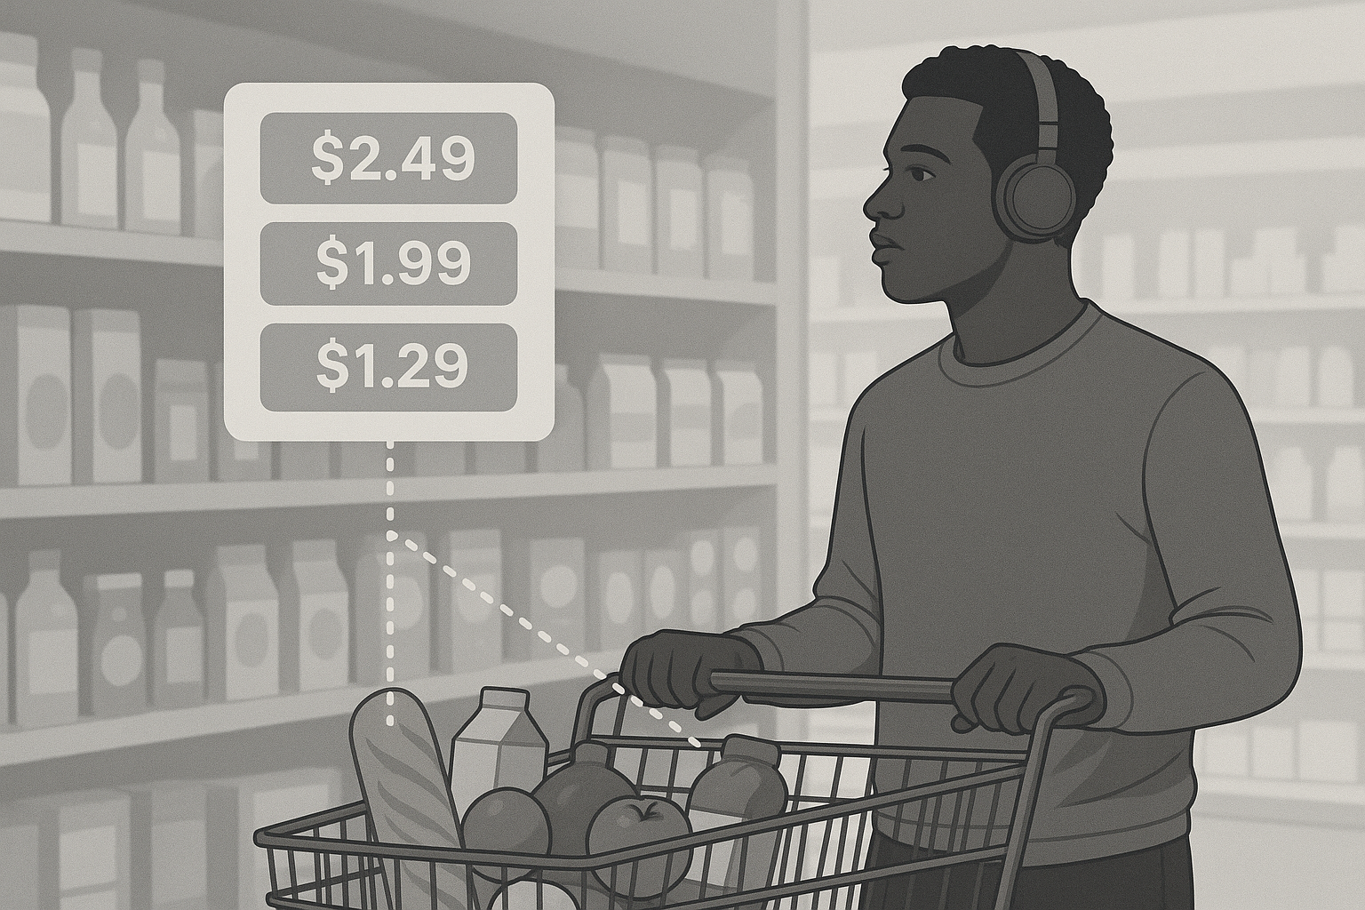

**SCENE TWO:**

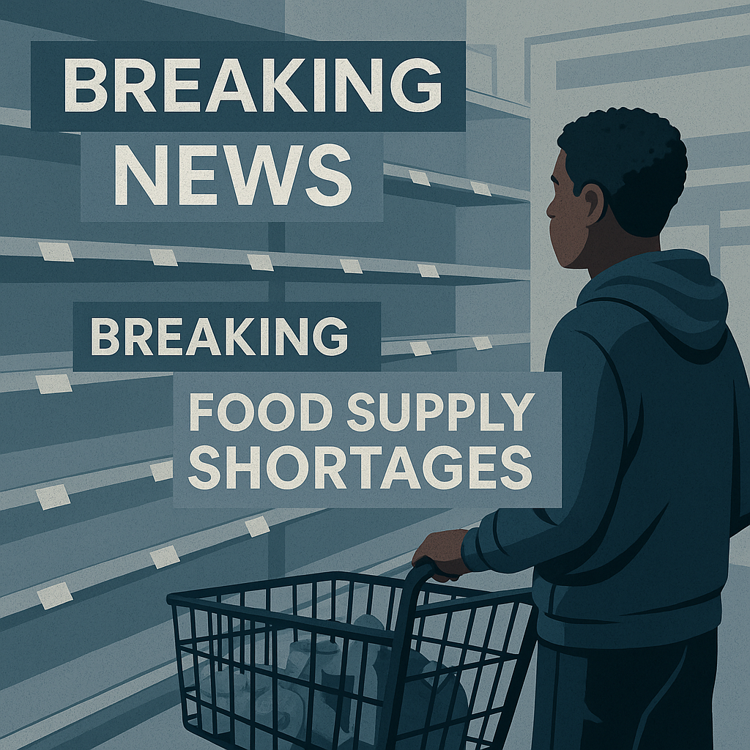

**SCENE THREE:**

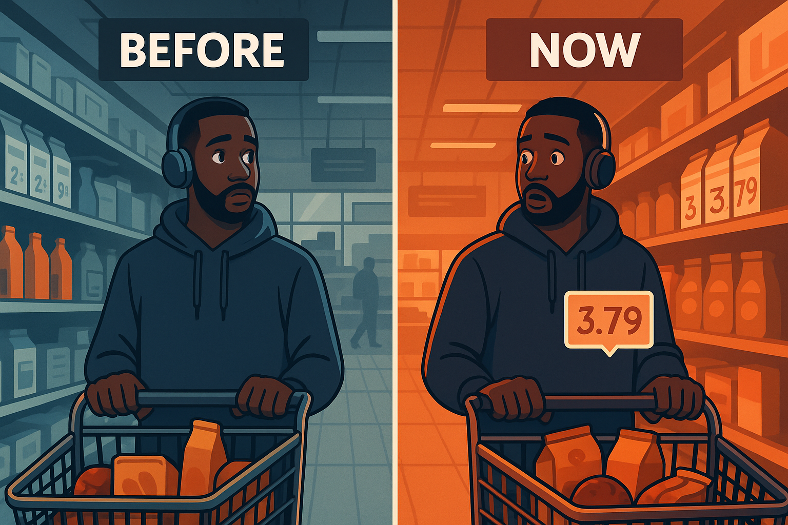

**SCENE FOUR: “FROM FARM TO SHELF”**

Ai in farms → Ai in warehouses → Ai in the stores.

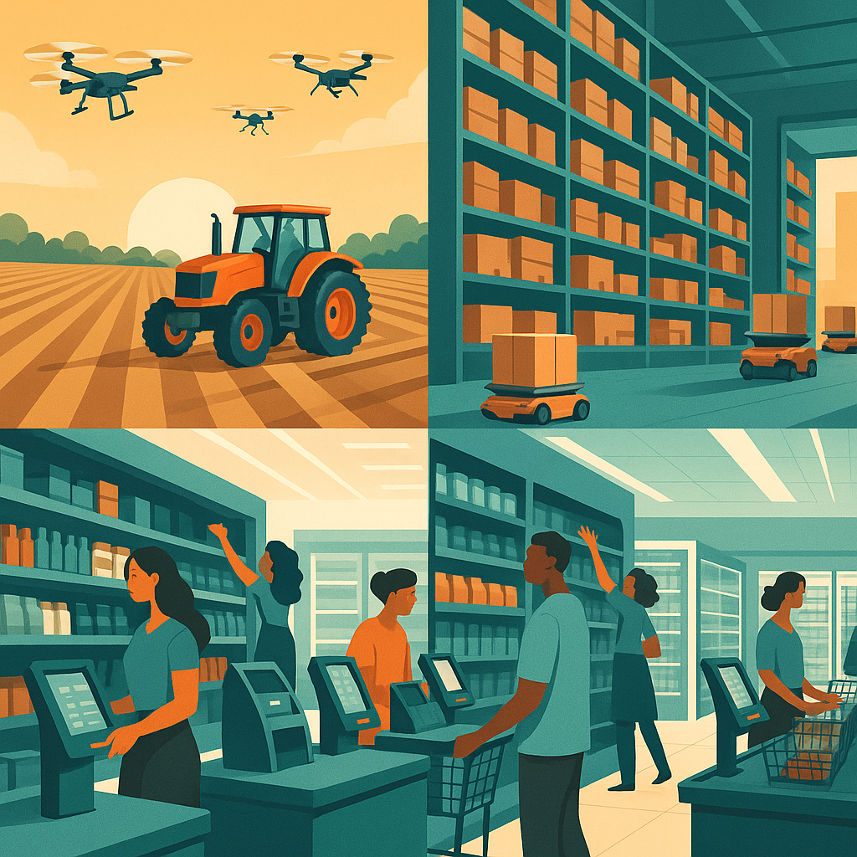

**SCENE FIVE :**

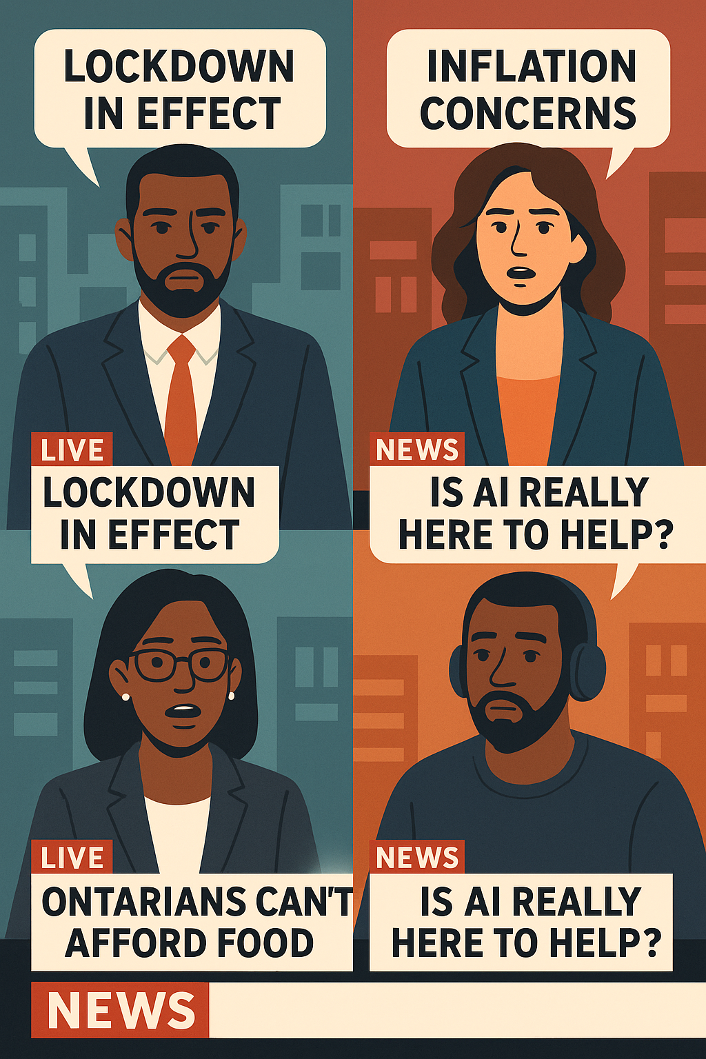

**SCENE SIX: Scrolly-telling + Voice-Over**

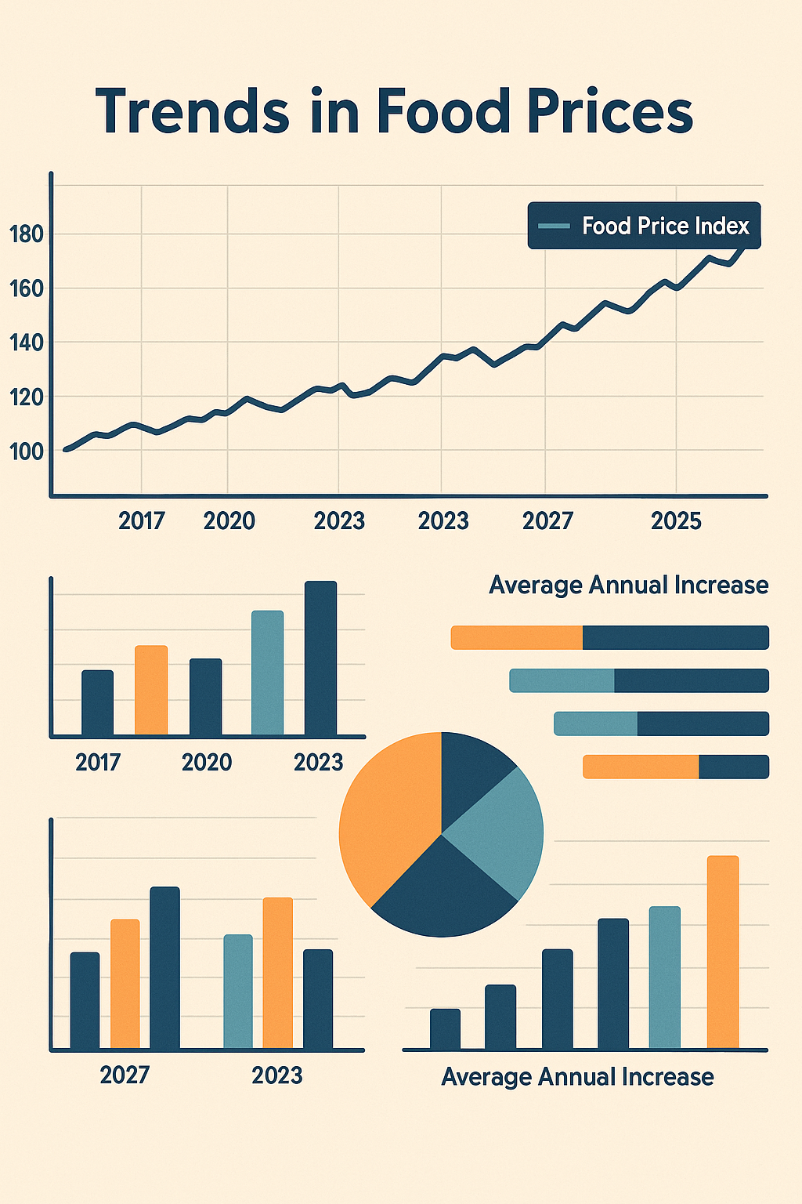

**SCENE SEVEN : INCREASED FOOD BANK USAGE**

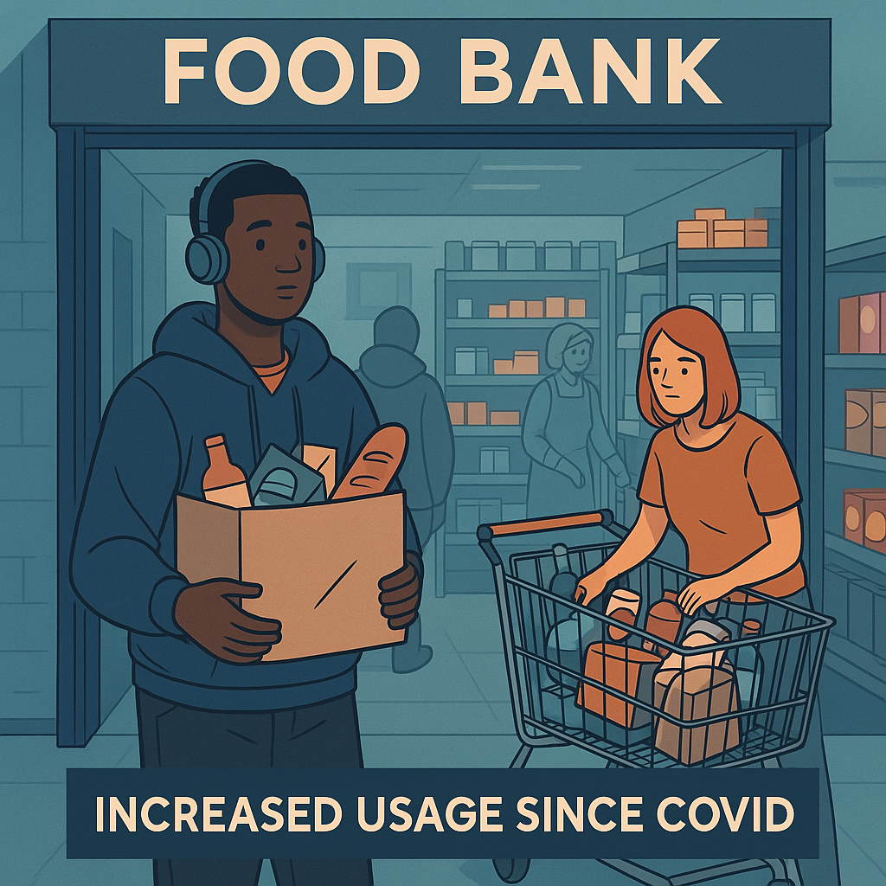

**SCENE EIGHT**

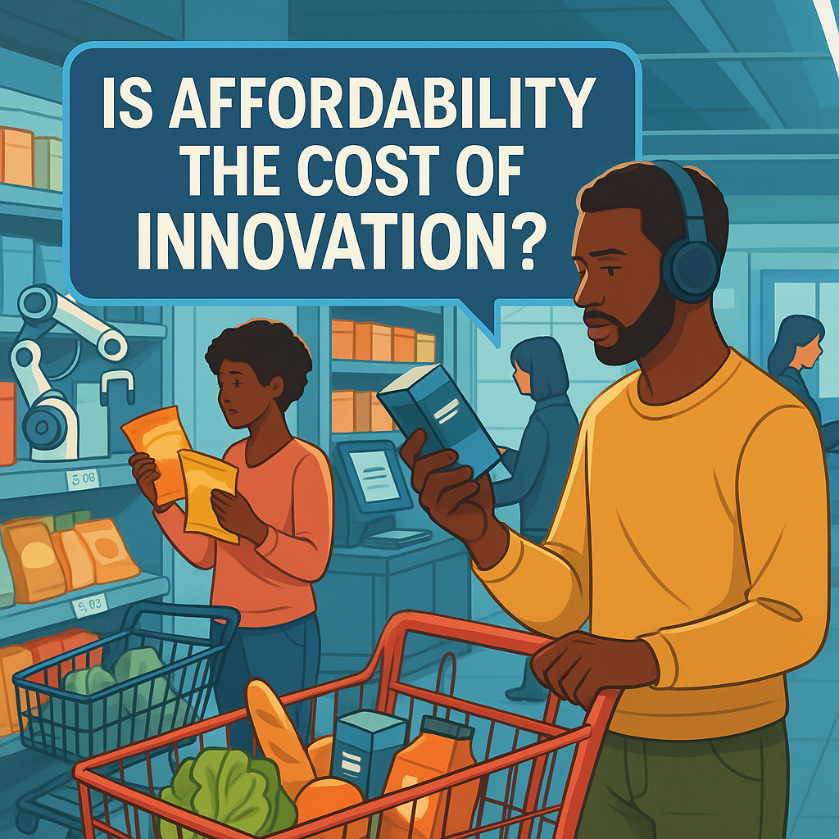

**SCENE NINE :**

